**ARRAYS**

SARTHAK SANAY

**(1) AIM:-**

To write programs in C to manipulate arrays (sorting, searching, insertion, deletion)

**CODE 1:- (Sorting -> Bubble Sort)**

**// Program in C to implement Sorting (Bubble Sort) in an array**

**#include <stdio.h>**

**int main()**

**{**

**int arr[5]= {34,128,64,101,56};**

**printf("Array before Sorting: \t\t");**

**for(int i=0; i<5; i++)**

**{**

**printf("%d\t", arr[i]);**

**}**

**// Implementing Ascending Bubble Sort**

**for(int i=0; i<5; i++)**

**{**

**for(int j=0; j<5-i-1; j++)**

**{**

**if(arr[j] > arr[j+1])**

**{**

**int temp= arr[j];**

**arr[j]= arr[j+1];**

**arr[j+1]= temp;**

**}**

**}**

**}**

**printf("\nArray after Bubble Sort: \t");**

**for(int i=0; i<5; i++)**

**{**

**printf("%d\t", arr[i]);**

**}**

**return 0;**

**OUTPUT SCREEN 1:-**

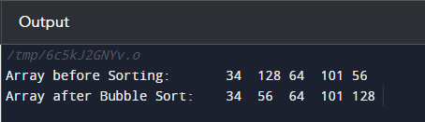

**CODE 2:- (Searching -> Linear Search)**

**// Program in C to implement Linear searching in an array**

**#include <stdio.h>**

**int main()**

**{**

**int c=0, n;**

**int arr[5]= {10,20,30,40,50};**

**printf("Enter number to check if it is an element of the array: ");**

**scanf("%d", &n);**

**for(int i=0; i<5; i++)**

**{**

**if(arr[i] == n)**

**{**

**printf("%d is present at index %d",n,i);**

**c=1;**

**}**

**}**

**if(c==0)**

**printf("%d is not present in the array.", n);**

**return 0;**

**}**

**OUTPUT SCREEN 2:-**

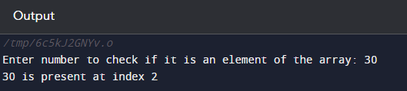

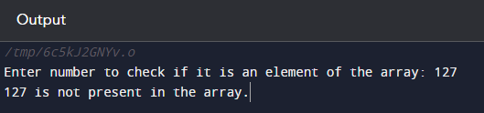

**P.T.O.**

**CODE 3:- (Insertion of element)**

**// Program in C to implement Insertion of an element at a specific position in an array**

**#include <stdio.h>**

**int main()**

**{**

**int arr[100]= {1,2,3,4,5,6,7,8,9,10};**

**int x, pos, n=10;**

**printf("Original Array:-\n");**

**for (int i=0; i<n; i++)**

**{**

**printf("%d ", arr[i]);**

**}**

**printf("\nEnter element to be inserted: ");**

**scanf("%d", &x);**

**printf("Enter position at which element has to be inserted: ");**

**scanf("%d", &pos);**

**n++; // increase the size by 1**

**// shifting elements forward**

**for (int i=n-1; i>=pos; i--)**

**{**

**arr[i] = arr[i-1];**

**}**

**arr[pos-1] = x; // inserting elements at pos**

**printf("Array after Insertion:-\n");**

**for (int i=0; i<n; i++)**

**{**

**printf("%d ", arr[i]);**

**}**

**return 0;**

**}**

**OUTPUT SCREEN 3:-**

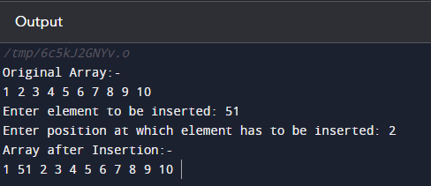

**P.T.O.**

**CODE 4:- (Deletion of element)**

**// Program in C to implement Deletion of an element in an Array from the desired position**

**#include <stdio.h>**

**int main()**

**{**

**int n, p;**

**printf("Enter size of array: ");**

**scanf("%d", &n);**

**int arr[n];**

**for(int i=0; i<n; i++)**

**{**

**printf("Enter element %d: ", i);**

**scanf("%d", &arr[i]);**

**}**

**printf("Original Array:-\n");**

**for(int i=0; i<n; i++)**

**{**

**printf("%d ", arr[i]);**

**}**

**printf("\nEnter index to be deleted: ");**

**scanf("%d", &p);**

**if (p >= n+1)**

**printf("Deletion not possible. Enter valid index position.\n");**

**else**

**{**

**for(int i=(p-1); i<(n-1); i++)**

**{**

**arr[i]= arr[i+1];**

**}**

**printf("Array after Deletion:- \n");**

**// for( c = 0 ; c < n - 1 ; c++ )**

**for(int i=0; i<n-1; i++)**

**{**

**printf("%d ", arr[i]);**

**}**

**}**

**return 0;**

**}**

**OUTPUT SCREEN 4:-**

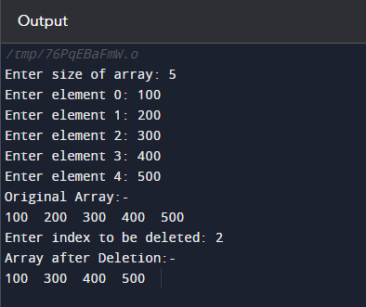

**(2) AIM:-**

To write programs in C to find the sum, average, maximum, and minimum values in an array.

**CODE 1:- (Sum)**

**// Program in C to find the sum of the values in an array**

**#include <stdio.h>**

**int main()**

**{**

**int n;**

**printf("Enter the size of the array: ");**

**scanf("%d", &n);**

**int arr[n];**

**for(int i=0; i<n; i++)**

**{**

**printf("Enter element %d: ",i);**

**scanf("%d", &arr[i]);**

**}**

**printf("The Array is:-\n");**

**for(int i=0; i<n; i++)**

**{**

**printf("%d ", arr[i]);**

**}**

**int sum= 0;**

**for(int i=0; i<n; i++)**

**{**

**sum+= arr[i];**

**}**

**printf("\nSum of the values: %d", sum);**

**return 0;**

**}**

**OUTPUT SCREEN 1:-**

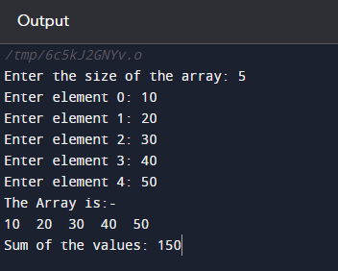

**CODE 2:- (Average)**

**// Program in C to find the average of the values in an array**

**#include <stdio.h>**

**int main()**

**{**

**int n;**

**printf("Enter the size of the array: ");**

**scanf("%d", &n);**

**int arr[n];**

**for(int i=0; i<n; i++)**

**{**

**printf("Enter element %d: ",i);**

**scanf("%d", &arr[i]);**

**}**

**printf("The Array is:-\n");**

**for(int i=0; i<n; i++)**

**{**

**printf("%d ", arr[i]);**

**}**

**int sum= 0;**

**for(int i=0; i<n; i++)**

**{**

**sum+= arr[i];**

**}**

**double avg= (double)sum/n;**

**printf("\nAverage of the elements: %.2f", avg);**

**return 0;**

**}**

**OUTPUT SCREEN 2:-**

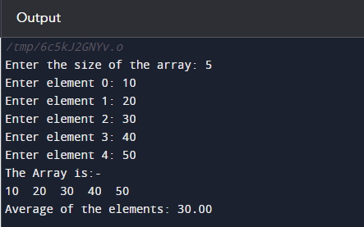

**CODE 3:- (Maximum)**

**// Program in C to find the maximum element in an array**

**#include <stdio.h>**

**int main()**

**{**

**int n;**

**printf("Enter the size of the array: ");**

**scanf("%d", &n);**

**int arr[n];**

**for(int i=0; i<n; i++)**

**{**

**printf("Enter element %d: ",i);**

**scanf("%d", &arr[i]);**

**}**

**printf("The Array is:-\n");**

**for(int i=0; i<n; i++)**

**{**

**printf("%d ", arr[i]);**

**}**

**int max= arr[0];**

**for(int i=0; i<n; i++)**

**{**

**if(arr[i]>max)**

**max= arr[i];**

**}**

**printf("\nMaximum value of the array is: %d", max);**

**return 0;**

**}**

**OUTPUT SCREEN 3:-**

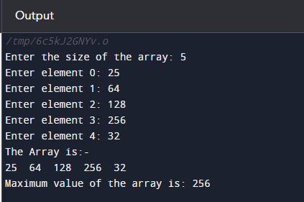

**CODE 4:- (Minimum)**

**// Program in C to find the minimum element in an array**

**#include <stdio.h>**

**int main()**

**{**

**int n;**

**printf("Enter the size of the array: ");**

**scanf("%d", &n);**

**int arr[n];**

**for(int i=0; i<n; i++)**

**{**

**printf("Enter element %d: ",i);**

**scanf("%d", &arr[i]);**

**}**

**printf("The Array is:-\n");**

**for(int i=0; i<n; i++)**

**{**

**printf("%d ", arr[i]);**

**}**

**int min= arr[0];**

**for(int i=0; i<n; i++)**

**{**

**if(arr[i]<min)**

**min= arr[i];**

**}**

**printf("\nMinimum value of the array is: %d", min);**

**return 0;**

**}**

**OUTPUT SCREEN 4:-**

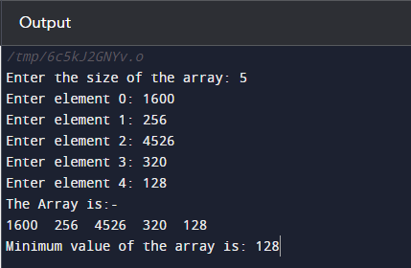

**(3) AIM:-**

To practice matrix operations in C using multi-dimensional arrays.

**CODE 1:- (Display 3D array as matrix)**

**// Program in C to display a three-dimensional array as a matrix**

**#include <stdio.h>**

**int main()**

**{**

**int m[3][3];**

**printf("Enter values for 3x3 matrix:-\n");**

**for(int i=0; i<3; i++)**

**{**

**for(int j=0; j<3; j++)**

**{**

**printf("Enter value for %d%d position: ", i,j);**

**scanf("%d", &m[i][j]);**

**}**

**}**

**printf("Three-dimensional array in Matrix format:-\n");**

**for(int i=0; i<3; i++)**

**{**

**for(int j=0; j<3; j++)**

**{**

**printf("%d ", m[i][j]);**

**}**

**printf("\n");**

**}**

**return 0;**

**}**

**OUTPUT SCREEN 1:-**

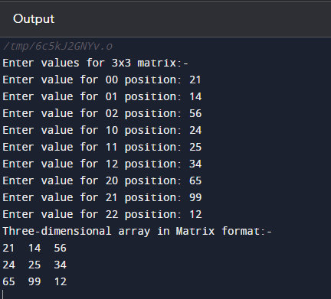

**P.T.O.**

**CODE 2:- (Matrix addition)**

**// Program in C to use a three-dimensional array for implementing matrix addition**

**#include <stdio.h>**

**int main()**

**{**

**int r,c;**

**printf("Enter the no of rows: ");**

**scanf("%d", &r);**

**printf("Enter the no of columns: ");**

**scanf("%d", &c);**

**int a[r][c], b[r][c];**

**printf("Enter values for first matrix\n");**

**for(int i=0; i<r; i++)**

**{**

**for(int j=0; j<c; j++)**

**{**

**printf("Enter value for %d%d position: ", i,j);**

**scanf("%d", &a[i][j]);**

**}**

**}**

**printf("Matrix A is as follows:-\n");**

**for(int i=0; i<r; i++)**

**{**

**for(int j=0; j<c; j++)**

**{**

**printf("%d ", a[i][j]);**

**}**

**printf("\n");**

**}**

**printf("Enter values for second matrix\n");**

**for(int i=0; i<r; i++)**

**{**

**for(int j=0; j<c; j++)**

**{**

**printf("Enter value for %d%d position: ", i,j);**

**scanf("%d", &b[i][j]);**

**}**

**}**

**printf("Matrix B is as follows:-\n");**

**for(int i=0; i<r; i++)**

**{**

**for(int j=0; j<c; j++)**

**{**

**printf("%d ", b[i][j]);**

**}**

**printf("\n");**

**}**

**printf("On performing addition operation on the two matrices A and B, we get:- \n");**

**for(int i=0; i<r; i++)**

**{**

**for(int j=0; j<c; j++)**

**{**

**printf("%d ", a[i][j]+b[i][j]);**

**}**

**printf("\n");**

**}**

**return 0;**

**}**

**OUTPUT SCREEN 2:-**

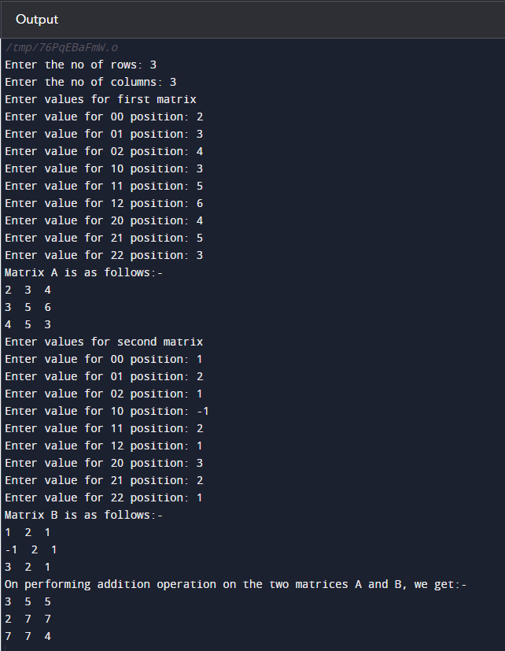

**CODE 3:- (Matrix Subtraction)**

**// Program in C to use a three-dimensional array for implementing matrix subtraction**

**#include <stdio.h>**

**int main()**

**{**

**int r,c;**

**printf("Enter the no of rows: ");**

**scanf("%d", &r);**

**printf("Enter the no of columns: ");**

**scanf("%d", &c);**

**int a[r][c], b[r][c];**

**printf("Enter values for first matrix\n");**

**for(int i=0; i<r; i++)**

**{**

**for(int j=0; j<c; j++)**

**{**

**printf("Enter value for %d%d position: ", i,j);**

**scanf("%d", &a[i][j]);**

**}**

**}**

**printf("Matrix A is as follows:-\n");**

**for(int i=0; i<r; i++)**

**{**

**for(int j=0; j<c; j++)**

**{**

**printf("%d ", a[i][j]);**

**}**

**printf("\n");**

**}**

**printf("Enter values for second matrix\n");**

**for(int i=0; i<r; i++)**

**{**

**for(int j=0; j<c; j++)**

**{**

**printf("Enter value for %d%d position: ", i,j);**

**scanf("%d", &b[i][j]);**

**}**

**}**

**printf("Matrix B is as follows:-\n");**

**for(int i=0; i<r; i++)**

**{**

**for(int j=0; j<c; j++)**

**{**

**printf("%d ", b[i][j]);**

**}**

**printf("\n");**

**}**

**printf("On performing subtraction operation on the two matrices A and B, we get:- \n");**

**for(int i=0; i<r; i++)**

**{**

**for(int j=0; j<c; j++)**

**{**

**printf("%d ", a[i][j]-b[i][j]);**

**}**

**printf("\n");**

**}**

**return 0;**

**}**

**OUTPUT SCREEN 3:-**

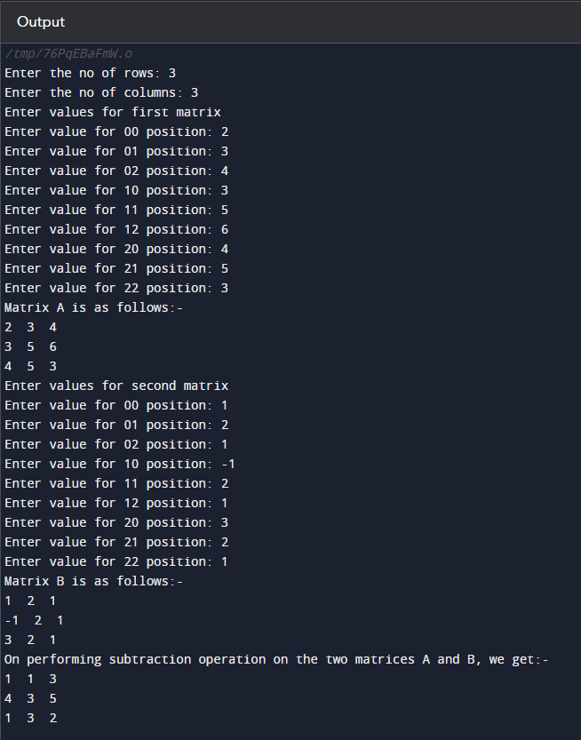

**CODE 4:- (Matrix Multiplication)**

**// Program in C to use a three-dimensional array for implementing matrix multiplication**

**#include <stdio.h>**

**int main()**

**{**

**int a[3][3], b[3][3], c[3][3];**

**printf("Enter values for first matrix\n");**

**for(int i=0; i<3; i++)**

**{**

**for(int j=0; j<3; j++)**

**{**

**printf("Enter value for %d%d position: ", i,j);**

**scanf("%d", &a[i][j]);**

**}**

**}**

**printf("Matrix A is as follows:-\n");**

**for(int i=0; i<3; i++)**

**{**

**for(int j=0; j<3; j++)**

**{**

**printf("%d ", a[i][j]);**

**}**

**printf("\n");**

**}**

**printf("Enter values for second matrix\n");**

**for(int i=0; i<3; i++)**

**{**

**for(int j=0; j<3; j++)**

**{**

**printf("Enter value for %d%d position: ", i,j);**

**scanf("%d", &b[i][j]);**

**}**

**}**

**printf("Matrix B is as follows:-\n");**

**for(int i=0; i<3; i++)**

**{**

**for(int j=0; j<3; j++)**

**{**

**printf("%d ", b[i][j]);**

**}**

**printf("\n");**

**}**

**// Matrix Multiplication and printing**

**printf("On Multiplication of Matrix A and B, we get:-\n");**

**for(int i=0;i<3;i++)**

**{**

**for(int j=0;j<3;j++)**

**{**

**c[i][j]=0;**

**for(int k=0;k<3;k++)**

**{**

**// You can use shorthand as well.**

**// c[i][j]+= a[i][k]*b[i][k];**

**c[i][j]= c[i][j] + (a[i][k]*b[k][j]);**

**}**

**printf("%d ", c[i][j]);**

**}**

**printf("\n");**

**}**

**return 0;**

**}**

**OUTPUT SCREEN 4:-**

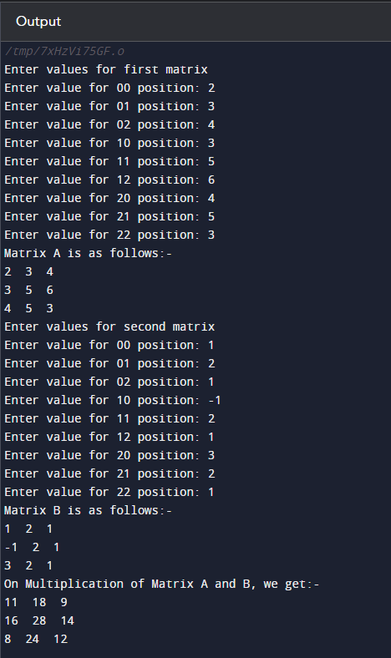

**CODE 5:- (Transpose of Matrix)**

**// Program in C to find the transpose of a matrix using three-dimensional arrays**

**#include <stdio.h>**

**int main()**

**{**

**int m[3][3];**

**for(int i=0; i<3; i++)**

**{**

**for(int j=0; j<3; j++)**

**{**

**printf("Enter value for %d%d position: ", i,j);**

**scanf("%d", &m[i][j]);**

**}**

**}**

**printf("Original Matrix:-\n");**

**for(int i=0; i<3; i++)**

**{**

**for(int j=0; j<3; j++)**

**{**

**printf("%d ", m[i][j]);**

**}**

**printf("\n");**

**}**

**printf("Transpose of Matrix:-\n");**

**for(int i=0; i<3; i++)**

**{**

**for(int j=0; j<3; j++)**

**{**

**printf("%d ", m[j][i]);**

**}**

**printf("\n");**

**}**

**return 0;**

**}**

**OUTPUT SCREEN 5:-**

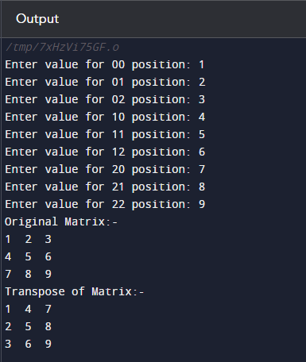

**(4) AIM:-**

To implement a program in C that merges two sorted arrays into a single sorted array.

**CODE:-**

**#include <stdio.h>**

**int main()**

**{**

**int n1,n2, temp=0;**

**printf("Enter size of 1st Array: ");**

**scanf("%d", &n1);**

**int a[n1];**

**printf("Enter elements of 1st Array:-\n");**

**for(int i=0; i<n1; i++)**

**{**

**printf("Enter element %d: ", i);**

**scanf("%d", &a[i]);**

**}**

**printf("Array 1 is: ");**

**for(int i=0; i<n1; i++)**

**{**

**printf("%d ", a[i]);**

**}**

**printf("\n\nEnter size of 2nd Array: ");**

**scanf("%d", &n2);**

**int b[n2], c[n1+n2];**

**printf("Enter elements of 2nd Array:-\n");**

**for(int i=0; i<n2; i++)**

**{**

**printf("Enter element %d: ", i);**

**scanf("%d", &b[i]);**

**}**

**printf("Array 2 is: ");**

**for(int i=0; i<n2; i++)**

**{**

**printf("%d ", b[i]);**

**}**

**// Sorting first array**

**for(int i=0; i<n1; i++)**

**{**

**for(int j=i+1; j<n1; j++)**

**{**

**if(a[i] > a[j])**

**{**

**temp= a[i];**

**a[i]= a[j];**

**a[j]= temp;**

**}**

**}**

**}**

**printf("\n\n1st array after sorting: ");**

**for(int i=0; i<n1; i++)**

**{**

**printf("%d ",a[i]);**

**}**

**// Sorting second array**

**for(int i=0; i<n2; i++)**

**{**

**for(int j=i+1; j<n2; j++)**

**{**

**if(b[i] > b[j])**

**{**

**temp= b[i];**

**b[i]= b[j];**

**b[j]= temp;**

**}**

**}**

**}**

**printf("\n2nd array after sorting: ");**

**for(int i=0; i<n2; i++)**

**{**

**printf("%d ",b[i]);**

**}**

**// Merging the two arrays**

**for(int i=0; i<n1; i++)**

**{**

**c[i] = a[i];**

**}**

**for(int i = 0; i<n2; i++)**

**{**

**c[i+n1] = b[i];**

**}**

**printf("\n\nThe merged array: ");**

**for(int i=0; i<(n1+n2); i++) //Printing the merged array**

**{**

**printf("%d ", c[i]);**

**}**

**// Sorting the merged array**

**printf("\nFinal merged array after sorting: ");**

**for(int i=0; i<(n1+n2); i++)**

**{**

**for(int j=i+1; j<(n1+n2); j++)**

**{**

**if(c[i] > c[j])**

**{**

**temp= c[i];**

**c[i]= c[j];**

**c[j]= temp;**

**}**

**}**

**}**

**for(int i=0; i<(n1+n2); i++) //Printing final array**

**{**

**printf("%d ",c[i]);**

**}**

**return 0;**

**}**

**OUTPUT SCREEN:-**

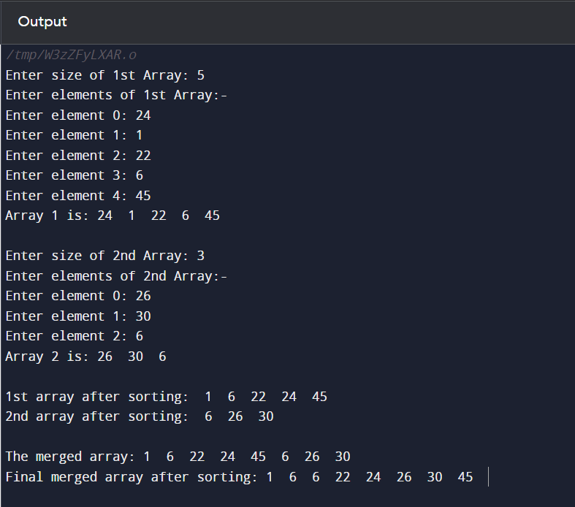

**(5) AIM:-**

To write a program to find the second largest element in an array.

**CODE:-**

**// Program in C to find out and print the second largest element in the array out of all the user input**

**#include <stdio.h>**

**int main()**

**{**

**int n;**

**printf("Enter the size of the array: ");**

**scanf("%d", &n);**

**int arr[n];**

**for(int i=0; i<n; i++)**

**{**

**printf("Enter element %d : ",i);**

**scanf("%d", &arr[i]);**

**}**

**printf("Array is:-\n");**

**for(int i=0; i<n; i++)**

**{**

**printf("%d ", arr[i]);**

**}**

**int lr= arr[0];**

**int slr;**

**int p=0;**

**for(int i=0; i<n; i++)**

**{**

**if(arr[i]>lr)**

**{**

**lr= arr[i];**

**p= i;**

**}**

**else**

**slr= arr[i-1];**

**}**

**for(int i=0; i<n; i++)**

**{**

**if(i!=p)**

**{**

**if(arr[i]>slr)**

**slr= arr[i];**

**}**

**}**

**printf("\nSecond largest element in the array is -> %d", slr);**

**return 0;**

**}**

**OUTPUT SCREEN:-**

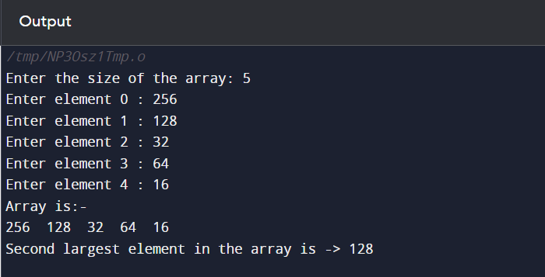

**(6) AIM:-**

To write a program to reverse the elements of an array.

**CODE:-**

**// Program in C to reverse the elements of an array**

**#include <stdio.h>**

**int main()**

**{**

**int n;**

**printf("Enter the size of the array: ");**

**scanf("%d", &n);**

**int arr[n];**

**for(int i=0; i<n; i++)**

**{**

**printf("Enter element %d: ",i);**

**scanf("%d", &arr[i]);**

**}**

**printf("Original Array:-\n");**

**for(int i=0; i<n; i++)**

**{**

**printf("%d ", arr[i]);**

**}**

**// Reversing the Array**

**for(int i=0, j=n-1; i<j; i++, j--)**

**{**

**int temp= arr[i];**

**arr[i]= arr[j];**

**arr[j]= temp;**

**}**

**printf("\nReverse of the Array:-\n");**

**for(int i=0; i<n; i++)**

**{**

**printf("%d ", arr[i]);**

**}**

**return 0;**

**}**

**OUTPUT SCREEN:-**

